A
Report
on
Project Fair
“AAVISHKAR-2023” organized by SSIP 2.0 cell,
Government Polytechnic, Godhra
On
14th June, 2023.

Project fair “AAVISHKAR-2023” has been organized by SSIP cell, Government Polytechnic, Godhra, for the final year students of Civil, Mechanical & Electrical engineering department on 14th June, 2023. The purpose of the event is to facilitate the projects of final year students. Also to encourage development of Innovative skills among the students.
The event was being inaugurated by Principal, Heads and Experts at 11.00 am in the auditorium hall. Key note lecture was delivered by The Principal and all HODs and invited experts.
Key note lecture delivered - “AAVISHKAR-2023”
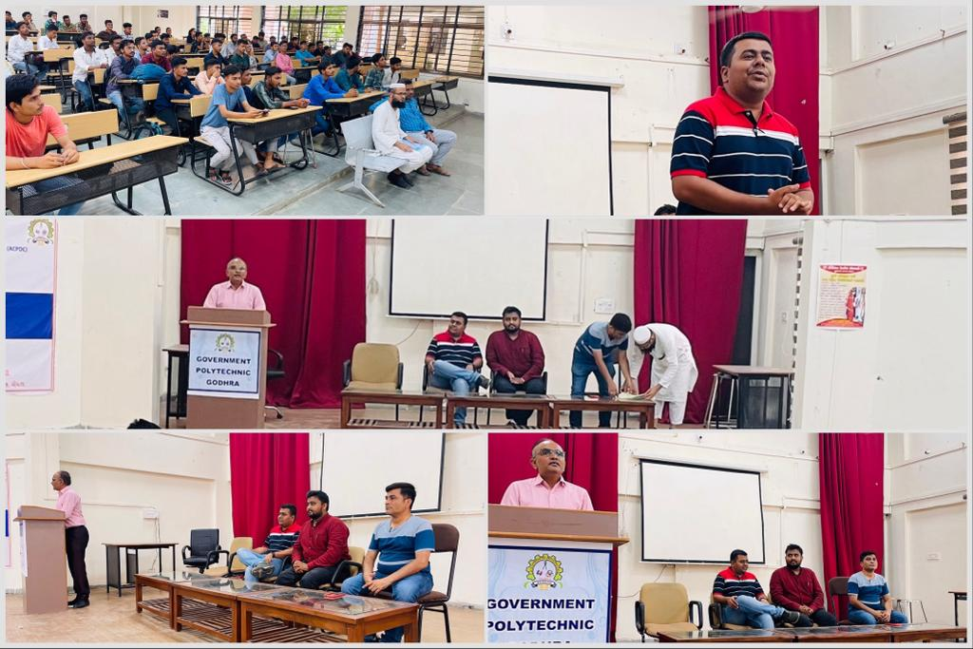

Models, Charts and Presentation prepared by participants were being exhibited.
Number of groups participated:
SR NO | DEPARMENT | TOTAL NO OF GROUPS
1 | MECHANICAL | 11
2 | ELECTRICAL | 9
3 | CIVIL | 10

Experts from different fields were being invited for the evaluation and ranking of student’s projects. Details of experts are as follows:
SR NO | DEPARMENT | NAME OF EXPERT | DESIGNATION
1 | CIVIL | Prof. V S SHAH | Assistant Professor, Civil Engineering department,  GEC Godhra.
2 | MECHANICAL | Prof.Dr. Amit Patel | Assistant Professor, Mechanical Engineering department,  GEC Godhra.
3 | ELECTRICAL | Prof. H. B. Surati | Assistant Professor,  Electrical Engineering department,  GEC Godhra.

The winners of the event are as follows:

SR NO | DEPARTMENT | PROJECT NAME | RANK
1 | CIVIL | Vishwakarma Yojna Phase-X (Tadava)  Vishwakarma Yojna Phase-X (Dalvada) | 1st
2 | CIVIL | Layout planning of our collage (GPG) | 2nd
3 | CIVIL | Traffic analysis of Shehra Bhagol level | 3rd
4 | MECHANICAL | 360º Rotation fire protection system | 1st
5 | MECHANICAL | Agriculture pesticides spraying vehicle | 2nd
6 | MECHANICAL | Solar scare crow | 3rd
7 | ELECTRICAL | Solar panel cleaner | 1st
8 | ELECTRICAL | Automatic irrigation drip system using node MSU (IoT based) | 2nd
9 | ELECTRICAL | Fire fighting robot | 3rd

Award given to Winners “AAVISHKAR-2023”
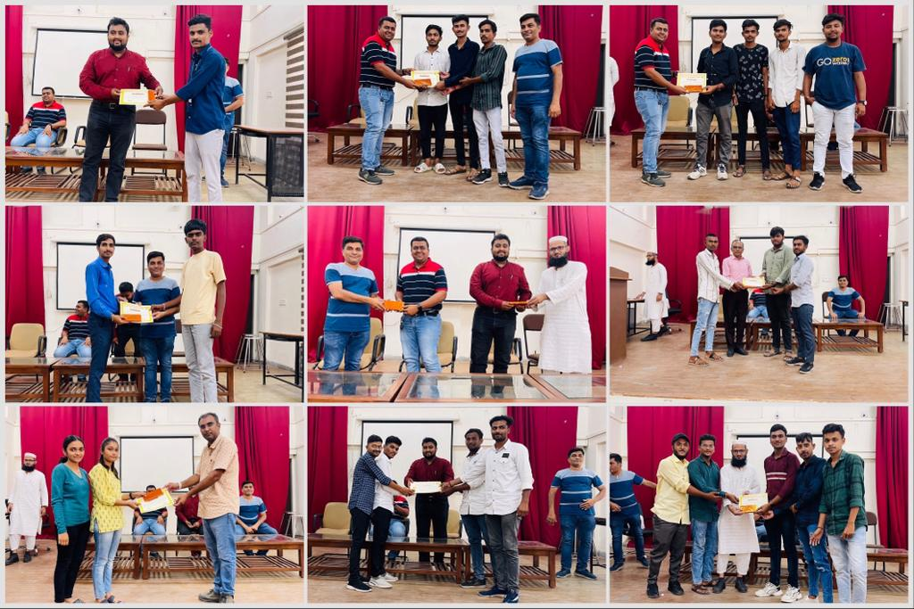

GLIMPSE OF THE EVENT “AAVISHKAR-2023”

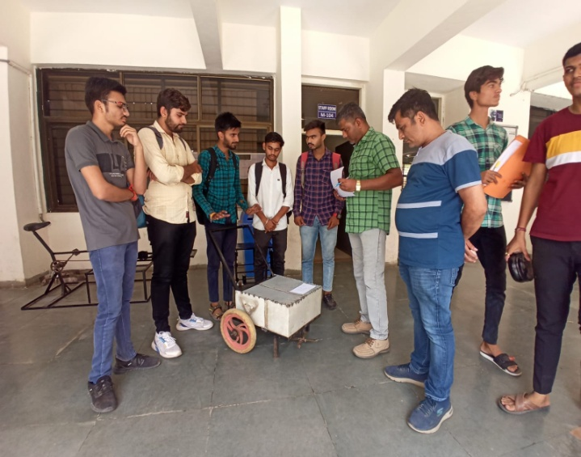 | 